Decision Making:

**An individual generally makes prompt decisions, while a group is dominated by various people, making decision-making very time consuming**. Moreover, assembling group members consumes lots of time. Individuals do not escape responsibilities. They are accountable for their acts and performance.

ccording to the idea of synergy, **decisions made collectively tend to be more effective than decisions made by a single individual**. Building on the psychological concept of gestalt, it is assumed that an organised whole is perceived as more than the sum of its parts. However, existing empirical results are mixed

|  |  |  |  |
| --- | --- | --- | --- |
| **Individual Decision Making** | | **Group Decision Making** | |
| Pros | Cons | Pros | Cons |
| Typically faster than group decision making | Fewer ideas | Diversity of ideas and can piggyback on others’ ideas | Takes longer |
| Best individual in a group usually outperforms the group | Identifying the best individual can be challenging | Greater commitment to ideas | Group dynamics such as groupthink can occur |
| Accountability is easier to determine | Possible to put off making decisions if left alone to do it | Interaction can be fun and serves as a teambuilding task | Social loafing–harder to identify responsibility for decisions |

**Herbert simon's model and principle of rationality**

Herbert Simon (1916-2001) is most famous for what is known to economists as **the theory of bounded rationality**, a theory about economic decision-making that Simon himself preferred to call “satisficing”, a combination of two words: “satisfy” and “suffice”.

He is widely associated with the theory of bounded rationality, which states that individuals do not make perfectly rational decisions because of both cognitive limits (the difficulty in obtaining and processing all the information needed) and social limits (personal and social ties among individuals).

**Simon's model defines four phases of decision-making process:**

Herbert Simon, the Nobel Prize winning researcher, showed that **humans went through three essential stages in the act of problem solving**. He called these the Intelligence, Design, and Choice stages. Decision making can also be considered as a type of problem solving.

* Intelligence Phase.
* Design Phase.
* Choice Phase.
* Implementation Phase

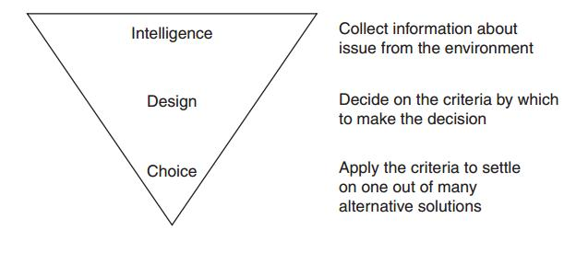

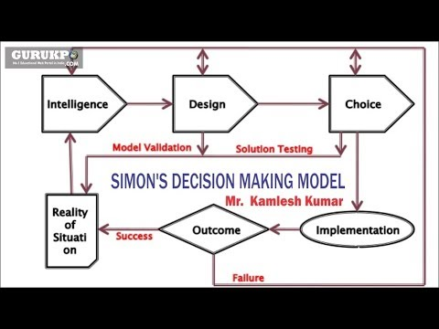

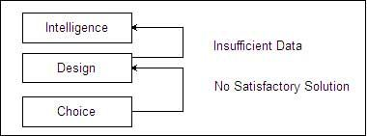

* [Intelligence Phase](https://ecomputernotes.com/mis/decision-making/explain-the-simons-model-of-decision-making#Intelligence_Phase)
* [Design Phase](https://ecomputernotes.com/mis/decision-making/explain-the-simons-model-of-decision-making#Design_Phase)
* [Choice Phase](https://ecomputernotes.com/mis/decision-making/explain-the-simons-model-of-decision-making#Choice_Phase)

**Intelligence Phase**This is the first step towards the decision-making process. In this step the decision-maker identifies/detects the problem or opportunity. A problem in the managerial context is detecting anything that is not according to the plan, rule or standard. An example of problem is the detection of sudden very high attrition for the present month by a HR manager among workers. Opportunity seeking on the other hand is the identification of a promising circumstance that might lead to better results. An example of identification of opportunity is-a marketing manager gets to know that two of his competitors will shut down operations (demand being constant) for some reason in the next three months, this means that he will be able to sell more in the market.

Thus, we see that either in the case of a problem or for the purpose of opportunity seeking the decision-making process is initiated and the first stage is the clear understanding of the stimulus that triggers this process. So if a problem/opportunity triggers this process then the first stage deals with the complete understanding of the problem/opportunity. Intelligence phase of decision-making process involves:  
**Problem Searching:** For searching the problem, the reality or actual is compared to some standards. Differences are measured & the differences are evaluated to determine whether there is any problem or not.  
**Problem Formulation:** When the problem is identified, there is always a risk of solving the wrong problem. In problem formulation, establishing relations with some problem solved earlier or an analogy proves quite useful.

**Design Phase**

Design is the process of designing solution outlines for the problem. Alternative solutions are designed to solve the same problem. Each alternative solution is evaluated after gathering data about the solution. The evaluation is done on the basic of criteria to identify the positive and negative aspects of each solution. Quantitative tools and models are used to arrive at these solutions. At this stage the solutions are only outlines of actual solutions and are meant for analysis of their suitability alone. A lot of creativity and innovation is required to design solutions.

**Choice Phase**

It is the stage in which the possible solutions are compared against one another to find out the most suitable solution. The ‘best’ solution may be identified using quantitative tools like decision tree analysis or qualitative tools like the six thinking hats technique, force field analysis, etc.

This is not as easy as it sounds because each solution presents a scenario and the problem itself may have multiple objectives making the choice process a very difficult one. Also uncertainty about the outcomes and scenarios make the choice of a single solution difficult.